BLINKIT DATASET
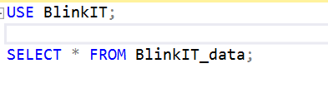
DATA CLEANING: Cleaning the Item_Fat_Content field ensures data consistency and accuracy in analysis. The presence of multiple variations of the same category (e.g., LF, low fat vs. Low Fat) can cause issues in reporting, aggregations, and filtering. By standardizing these values, we improve data quality, making it easier to generate insights and maintain uniformity in our datasets.
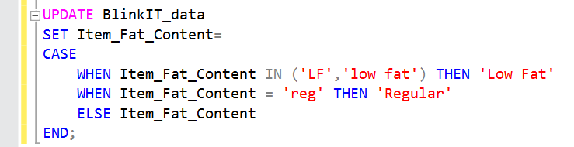
TO check it is update or not :
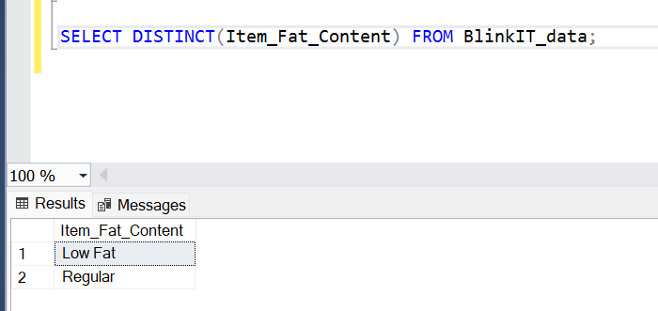

SQL QUERY FOR KPI’S
Total sales:
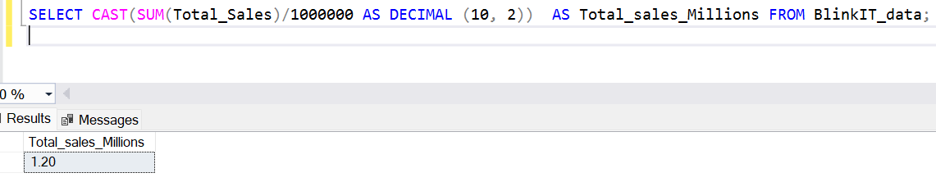
Average sales:
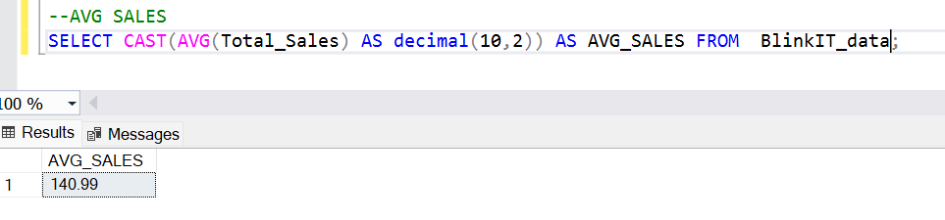
Number of Items:
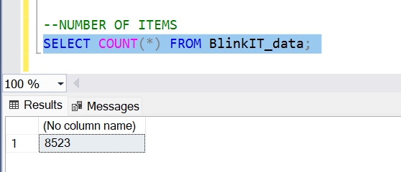
Total sales by fat content
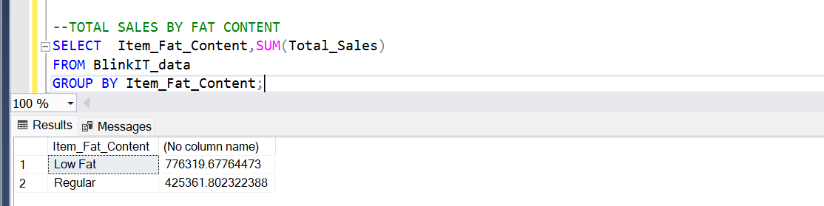
Sales and other metrices
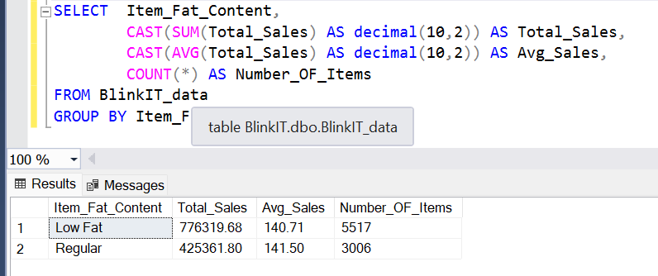
Sales by Item Type
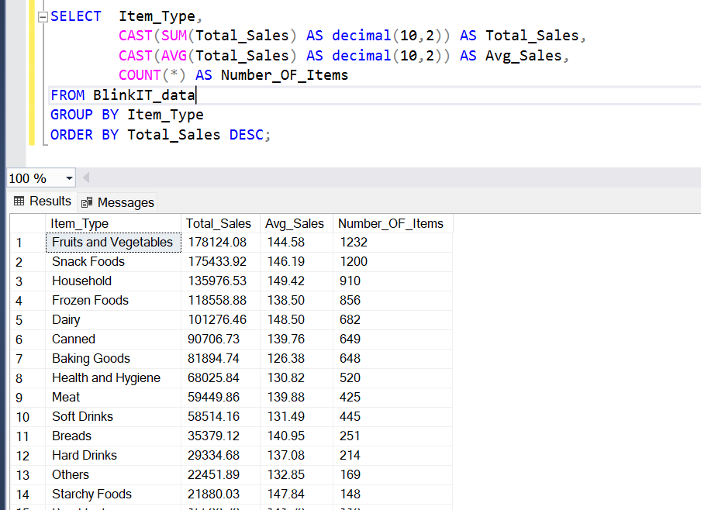
TO SEE TOP 5 ITEMS
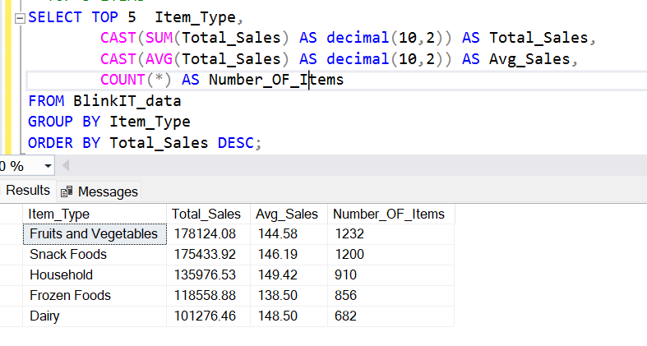
Fat content by outlet for total sales
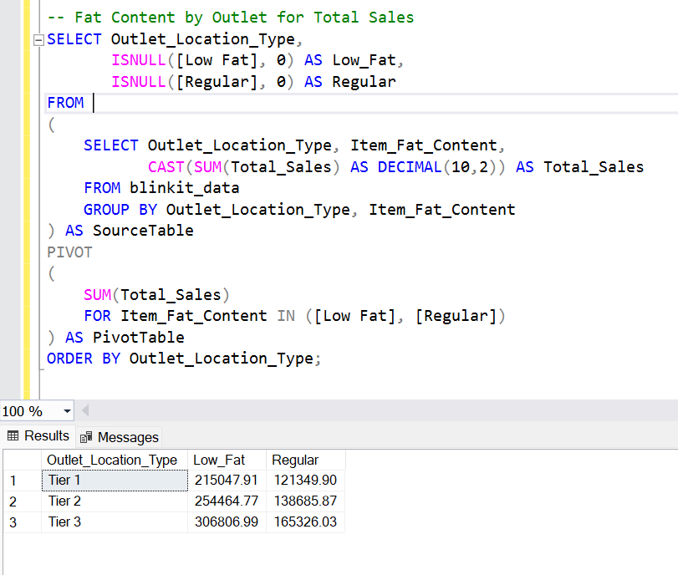
Total Sales by Outlet Establishment
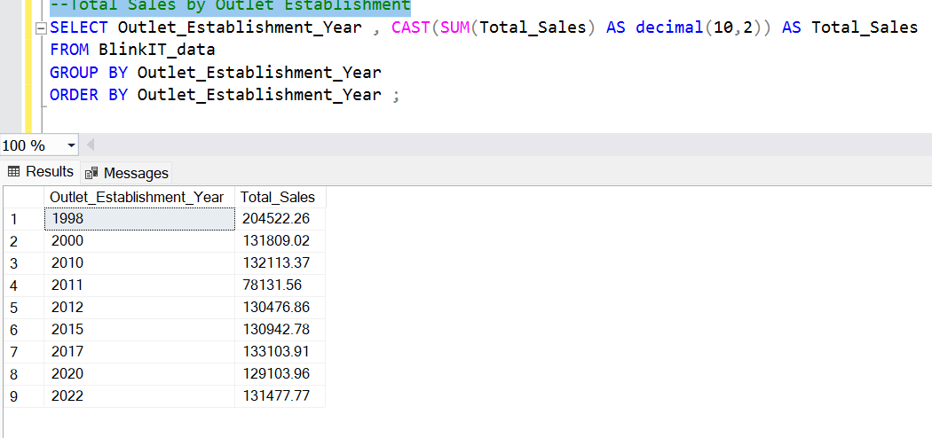
Percentage of Sales by Outlet Size:
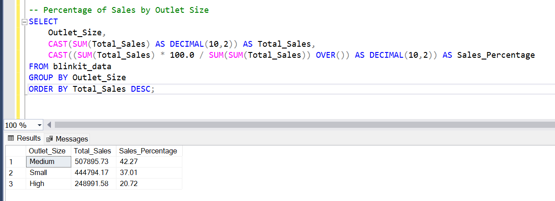
Sales by Outlet Location
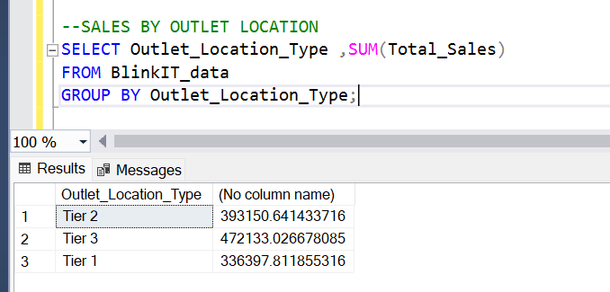

All metrics by outlet type
